The Title should be Bold and Centered (Times New Roman in 14pt)

F. Author¹, S. Author², and T. Author² (Times New Roman in 11pt)
¹ Graduate School of Engineering, University of SIMS, 1-1 Chiyoda, Tokyo 100-0001 Japan;
²Institute of Atom Probe, 1-7 Nagata-cho, Chiyoda, Tokyo 100-0014 Japan (Italicized Times New Roman in 11pt)
Corresponding-author@sims.edu (Times New Roman in 11pt without hyperlink)

1. Layout and file settings
This page presents instructions for preparing camera-ready abstracts for SISS-20. All abstracts should be prepared as a Microsoft Word document file (.doc) using the following guidelines. Preferred formats of submitting abstracts are .doc and .pdf.
The length must be one or two page(s) including figures and tables. Color figures are acceptable only in the online version. Please make sure that your abstract will be printed in monochrome. Use ISO A4 (210 mm x 297 mm) size paper, making sure that there is a margin of 2.5 cm on top/bottom/left/right sides. As the default setting of this file, we recommend embedding all the fonts used in your abstract.

2. Format of title, author(s), and affiliation(s)
The Document should begin with the following items in this order: Abstract Title, Author(s), Affiliation(s), and Main Text.
The Abstract Title should be bold, centered, and as concise as possible. Add a blank line before the author list. The Author(s)’ name(s) should be listed with the first initials only, followed by the last names in full. Author(s) should be separated by commas. Center the author(s) list and underline the name of the presenting author. Affiliations should follow on the next line without a blank line. For each affiliation, the maximum level of detail should be the name of the organization, institute, or department, and full street address. Affiliations should be italicized and centered. Use superscript numbers as the key to the affiliated organizations, if needed. The numbers should appear after each author’s name and before each affiliation. The corresponding author’s e-mail address must be included on the next line and underlined without a hyperlink.

3. Format of the main text
In the main text, Times New Roman font in 11pt size and single line spacing should be used. Use Symbol font for Greek letters. Otherwise, the main text can be written in free format. Samples of tables, figures, equations, and references are shown in this text.

4. Embedding fonts
Embedding fonts are recommended. Using the default setting of this template file, the fonts will be embedded in your abstract. If the case of changing the settings, you can refer to following link to embed the fonts in your abstract: http://www.idautomation.com/kb/ttf_embedding.html.

5. Sample
Sample Sample Sample Sample Sample Sample Sample Sample Sample Sample Sample Sample Sample Sample Sample Sample Sample Sample Sample Sample Sample Sample Sample Sample Sample Sample Sample Sample Sample Sample Sample Sample Sample Sample Sample Sample

Table 1. Table caption (Times New Roman in 11pt) above is preferable to be centered.
 | A = 0.56 | B = 0.69 | C = 0.75 | D = 0.100
AB₁ | 14.0640 | 18.5620 | 22.0817 | 18.90732
DA₅ | 246.7889 | 255.9483 | 284.6633 | 262.24264

Sample Sample Sample Sample Sample Sample Sample Sample Sample Sample Sample Sample Sample Sample Sample Sample Sample Sample Sample Sample Sample Sample Sample Sample Sample Sample Sample Sample Sample Sample Sample Sample Sample Sample Sample Sample Sample Sample Sample Sample Sample
Sample Sample Sample Sample Sample Sample Sample Sample Sample Sample Sample Sample Sample Sample Sample Sample Sample Sample Sample Sample Sample Sample Sample Sample Sample Sample Sample Sample Sample Sample Sample Sample Sample Sample Sample Sample Sample

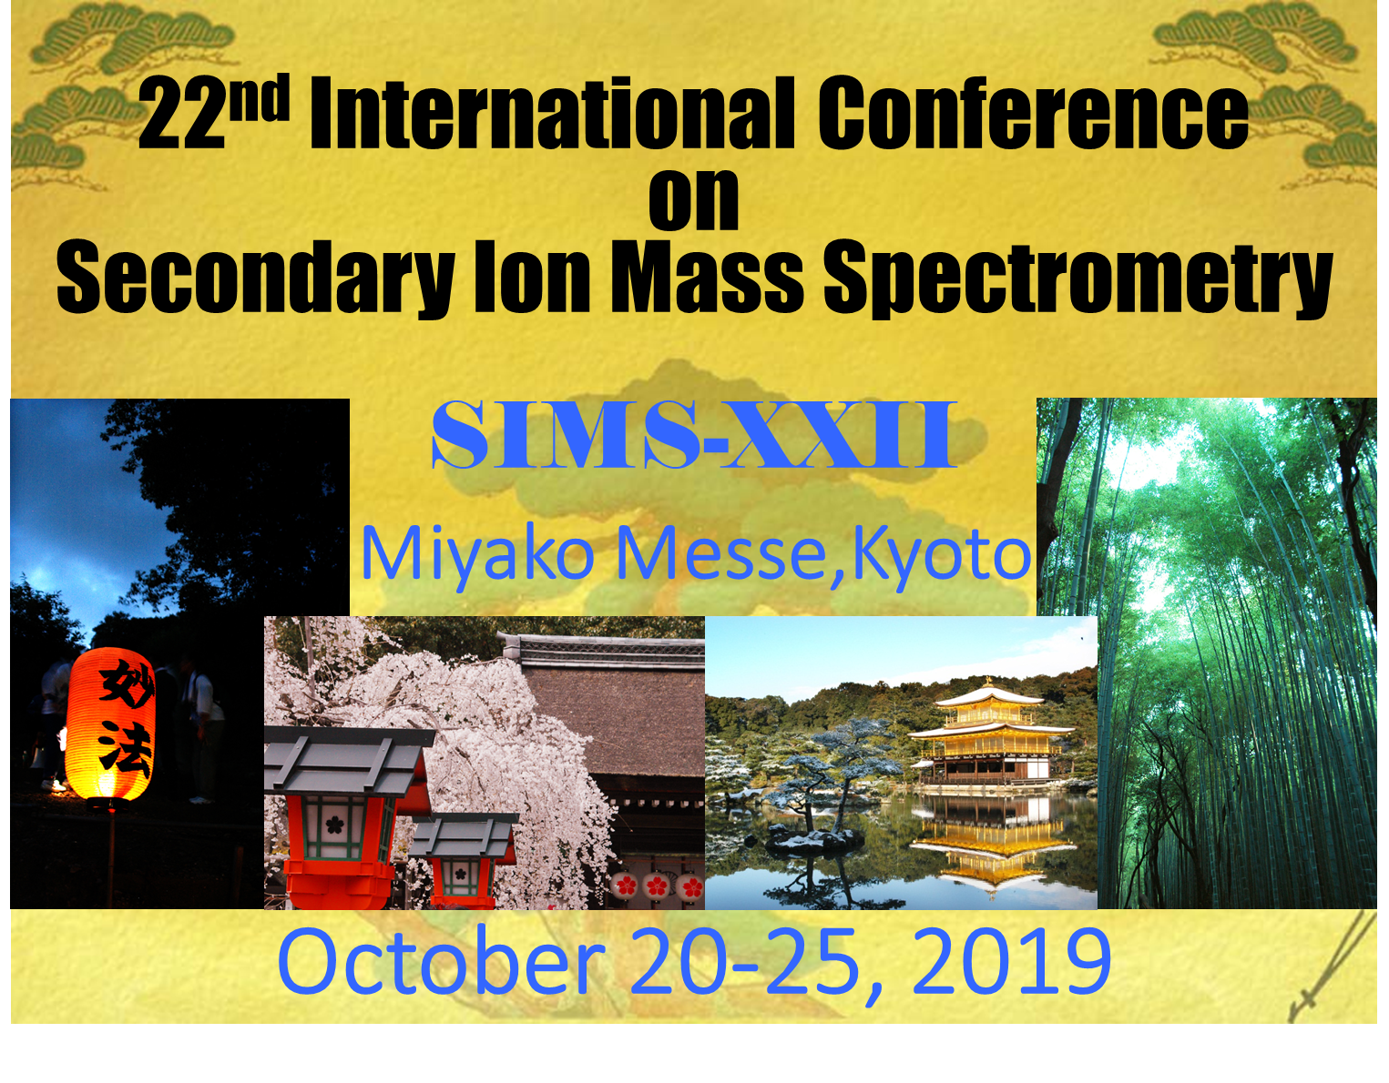
Figure 1. Figure caption (Times New Roman in 11pt) below is preferable to be centered

Sample Sample Sample Sample Sample Sample Sample Sample Sample Sample Sample Sample Sample Sample
Displayed equations, e.g., “Eq.(1)” are preferable to be indented or centered.
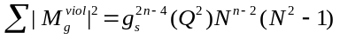 (1)
Sample Sample Sample Sample Sample Sample Sample Sample Sample Sample Sample Sample Sample Sample Sample Sample Sample Sample Sample Sample Sample Sample Sample Sample

References
Times New Roman font in 11pt should be used. All of the references are recommended to be numbered in the order that they appear in the abstract. It is recommended to use numbers in square brackets in the text where a paper is cited (e.g., [1]).

[1] You can write each item in free format.
[2]…

